The Silver Surfer
Reading Guide for In Thy Name

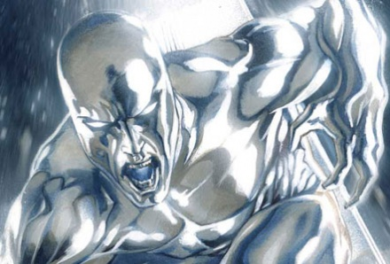
CHARACTER BACK-STORY:
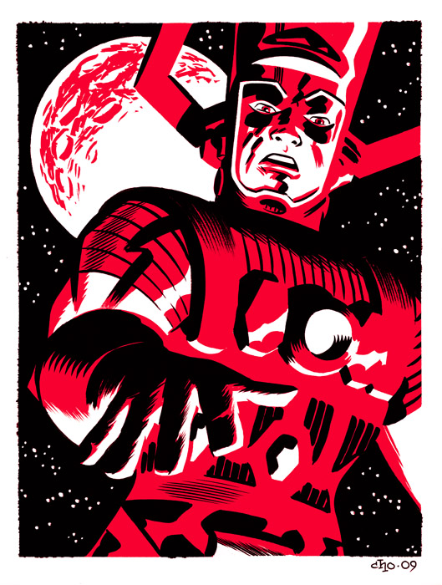
The Silver Surfer mythology begins on a far-away planet called Zenn-la, inhabited by a benevolent race of beings that are technologically and culturally progressive. Within this civilization, our hero Norrin Radd begins to wonder about the nature of existence and the point of living out a life relatively free from struggle. Like a fantasy Siddhartha/Buddha, Radd feels alienated by his lavish yet lackluster life, even though he cherishes his beloved girlfriend, Shalla-Bal. But one day, Radd finds his restless pondering put to the test when Galactus, the Devourer of Worlds, arrives to consume Zenn-la and to destroy all of its inhabitants. Radd appeals to Galactus and volunteers to become his herald, sacrificing himself in order to save Zenn-la. Galactus transforms Radd into the Silver Surfer, a creature possessing “the power cosmic” who will serve Galactus by finding worlds for him to eat. Eventually, the Surfer rebels against Galactus and is banished to wander the Earth and then the Universe, a homeless yet noble sentinel of the stars who uses his powers to fight evil and foster good wherever his travels lead him.
ABOVE: Norrin Radd transformed into the Surfer (from the “Silver Surfer” entry on Marvel.com.)

TIPS ON READING IN THY NAME: The visual storytelling of the best comic books combines pictures and text in a dynamic back-and-forth action — most story panels run from left to right on the left and then the right-hand sides of the book, but some panels stretch completely across the entire spread of the book, so watch closely. Take time also to soak up the images and understand how they work together with narration (in square boxes) and dialogue (in balloons) to tell the whole story. Notice also that, from time to time, the story breaks into flashbacks, in which the panels are slightly shaded to suggest aging memories that have lost some color. In Thy Name is imaginative science fiction that stretches the horizons of fantasy with wild images that require visual and mental attention.
“GALACTUS” by Cho

OTHER CHARACTERS APPEARING IN SILVER SURFER: IN THY NAME:
THE EMPRESS: leader of the AMA Collective
RUQTAR KOIL: an “Explorocrat” in the AMA Collective
TOL-WES: a creature from the planet Brekknis
FANTASY TERMS FROM IN THY NAME:
ACCORDITE: a social class on the planet Brekknis
THE AMA COLLECTIVE: a utopian empire based in the planet AMA Prime
ANVILCRAFT: Brekknis warships
THE BINARC: the AMA Collective’s two goals in expanding and bringing others into their group
BLURPOOON: an Organpirate weapon, like a harpoon
DATAHOARD: a social class in the AMA Collective (like THINKMASTERS and COMMUNOCRATS)
ETHERCOMS: wireless psychic communications
EXPLOROCRAT: a royal office in the AMA Collective
FIELD-SPAR: the AMA Collective martial art
FRACTAL SUIT: battle technology that creates the illusion of many decoy-bodies
HAZEGARDEN: an patch of vegetation in the AMA Collective
HUSKWEAR: Brekknis war armor
KOLQAMIST: a beverage from the AMA Collective
MISTPADDLER: a creature in the AMA Collective
PSI-LOBE: a piece or section of a brain, sought after by “ORGANPIRATES”
PSIMUSIC: psychic or virtual music

WORDS FROM IN THY NAME FOR YOU TO KNOW OR LOOK UP:
ABHOR SYNAESTHETIC
ANIMA TALISMAN
APEX UTOPIA
BESTIARY VENGEANCE
CALLOUS ZEAL / ZEALOTRY
CHAMBERLAIN
COLLECTIVE
COURTIER
CULLS
DECORUM
DERVISH
DESPOT
DISSIDENT
DIVINITY
DOGMA
ETIQUETTE
FAÇADE
GENOCIDE
GERMINATE
IOTA
LITURGY
MOTTLED
ORDNANCE
PRISM
PUERILE
POGROM
SCOURGE
SENTIENCE / SENTIENT
SINGULARITY
SIPHON
SORDID
STAGNATION
SUCCUMB

Works Cited

Cho, Michael. “Galactus.” Jack Kirby Museum. 2009. 2 October 2009 <http://kirbymuseum.org/blogs/kirby-vision/?paged=2>.
Lee, Stan, and John Buscema. Marvel Masterworks Presents the Silver Surfer. Vol. 1. NY: Marvel Publishing, Inc. 1967.
“Silver Surfer.” Marvel.com 2009. 2 October 2009 <http://marvel.com/universe/Silver_Surfer>.
Spurrier, Simon, and Tan Eng Huat. Silver Surfer: In Thy Name. NY: Marvel Publishing, Inc., 2007.
Starlin, Jim, and Ron Lim. The Silver Surfer: Rebirth of Thanos. NY: Marvel Publishing, Inc., 1977.
Straczynski, J. Michael, and Esad Ribic. Silver Surfer: Requiem. NY: Marvel Publishing, Inc., 2007.

